ZEPTO
Business Performance Analysis
2024-25

___________________________________________________________
Tools Used: python (pandas, NumPy, Seaborn, Matplotlib)
Data Period: January 2024-March 2025(15 Months)

Table of contents.
- Executive summary
- About Company
- Methodology & Tools
- Analysis.
- Monthly Revenue & Trend Analysis.
- Daily Orders Analysis.
- Market share Growth Analysis.
- Market time (optimization) Analysis.
- Dark Stores Analysis.
- Correlation Analysis.
- Revenue Growth % (Monthly).
- Key Insights & Findings.
- Recommendations.
- Conclusion.

      - Executive Summary.
This report presents a comprehensive performance analysis of Zepto, india’s leading quick-commerce platform, for the fiscal period January 2024 to March 2025. Leveraging a 15-month dataset and python-based data analytics (pandas, Matplotlib, seaborn) this study examines Zepto’s growth trajectory across revenue, operation, customer engagement, and market positioning.
Zepto achieved a 139% revenue growth in just 15 months (Jan 2024-mar 2025), scaling from ₹ 661 Cr to ₹ 1,578 Cr monthly revenue. Daily Orders doubled from 5.2L to 10.5L, delivery time dropped from 12 to 8 minutes, and market share jumped from 21% to 33% the dataset contains zero missing values across 15 records and 13 metrics, confirming high data integrity.

Metric | Jan 2024 | Mar 2025 | Change
Monthly Revenue (Cr INR) | 661 | 1,578 | +139%
Orders per Day | 5,20,000 | 10,50,000 | +1
Avg. Order Value (INR) | 410 | 485 | +18%
Delivery Time (min) | 12 | 8 | -33%
Customer Retention (%) | 61% | 76% | +15pp
Dark Stores | 350 | 850 | +143%
Active Cities | 10 | 20 | +100%
App Downloads (millions) | 2.1 | 5.5 | +162%
Market Share (%) | 21% | 33% | +12pp

      - About Company.
Zepto is an Indian quick-commerce company that delivery groceries and daily essentials within 10 minutes to customers in major metropolitan cities across India.

Founded: July 2021 in Mumbai.
Founders: Aadit Palicha started KiranaKart with Kaivalya Vohra — Stanford University dropouts who just 17 when they started
Headquarters: Bengaluru, Karnataka, India (moved from Mumbai in 2024)
Industry: Quick-commerce / Online grocer
Valuation: $5billion (as of August2024)
Revenue: ₹9,366 crore (~US$980 million) in 2025
Employees: ~16,898 (as of March 2026)
Stores: 1,000+dark stores across 10+ metro cities
Funding: Over $1.5 billion raised total; $1 billion raised in 2024 alone (Series F: $665M at $3.6B + $340M at $5B)

Core Business Model
- Dark stores: Zepto fulfils orders using a network of strategically located micro-warehoues, allowing for highly optimized and rapid last-mile delivery.
- Speed: The company guarantees lightning-fast delivery speed, historically popularized by its flagship “10-minute delivery” promise
- Product Catalog: Users can order from an extensive catalog including groceries, dairy, snacks, electronics, and beauty products.
- Zepto Café: An extension of their service that provides curated ready-to-eat food and a quick-service coffee menu. [1, 2, 3, 4, 5, 6]

Company Growth & Financials
- Valuation: Zepto is valued at over $5 billion to $7 billion and has raised massive funding from global investors.
- Expansion: They operate hundreds of dark stores across dozens of major metropolitan areas in India.
- Market Competition: Zepto competes against other major Indian quick-commerce platforms like Blinkit and Swiggy Instamart. [1, 2, 3, 4]
If you are thinking about using their service, would you like to:
- Download the app on the ⁠Zepto
- Learn more about their career opportunities on their ⁠LinkedIn profile?
- Explore how they compare with other major Indian quick-commerce competitors? [1]

      - Methodology & Tools Used

Library | Use in project
Pandas | Data loading, EDA (head, describe, info, isnull)
Matplotlib | Line, bar dual-axis charts
seaborn | Correlation heatmap
NumPy | Numerical operation

Steps followed: Load CSV → EDA → Null check → Feature engineering
(Revenue Growth %) → Visualization.

      - Analysis.

- Monthly Revenue & Trend Analysis
Print(df[‘Monthly_Revenue_cr’].sum())
15857 Cr

- Trend analysis
plt.figure(figsize=(12,6))
sns.lineplot(x='Month', y='Monthly_Revenue_Cr', data=df, marker='o')
plt.xticks(rotation=45)
plt.title('Monthly Revenue Trend')
plt.xlabel('Month')
plt.ylabel('revenue (cr)')
plt.tight_layout()
plt.show()

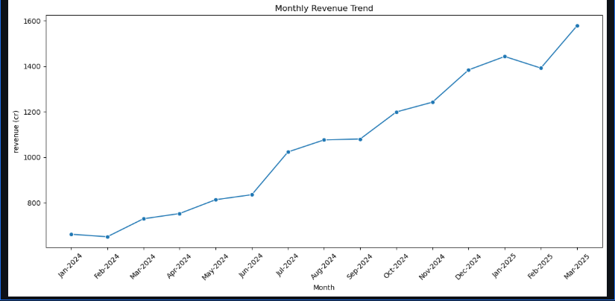

Insight to write: Revenue grew consistently from ₹661 Cr → ₹1,578 Cr. The top 5 revenue months were all in late 2024–early 2025 (Mar 2025 being highest). Only Feb 2024 and Feb 2025 saw minor dips due to fewer days in the month. July 2024 had the sharpest single-month jump (+22.5% MoM) — likely due to monsoon demand and post-funding expansion.

- Daily Orders Analysis.
plt.figure(figsize=(12,6))
sns.barplot(x='Month', y='Orders_Per_Day', data=df)
plt.title('Daily orders analysis')
plt.xlabel('month')
plt.ylabel('orders per day')
plt.tight_layout()
plt.show()

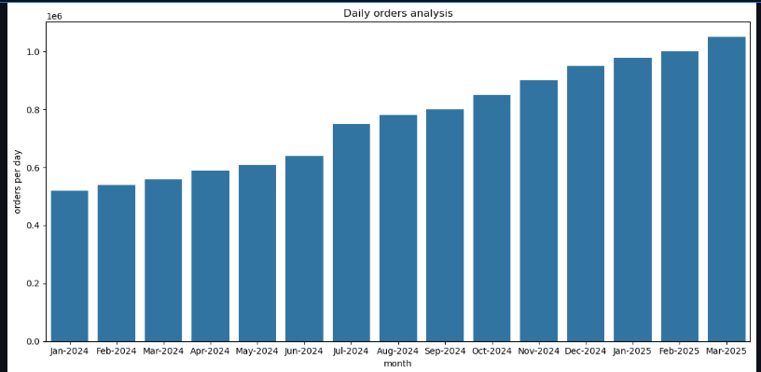

Insight to write: Daily orders grew from 5.2 lakh to 10.5 lakh (+102%). Monthly order volumes crossed 3 Cr for the first time in Mar 2025. Growth accelerated after June 2024 — coinciding with the $665M funding round — suggesting capital deployment directly fueled order volume scale.

- Market share Growth Analysis.
plt.figure(figsize=(12,6))
sns.lineplot(x='Month', y='Market_Share_%', data=df, marker='o')
plt.xticks(rotation=45)
plt.title('Market Share Growth')
plt.xlabel('Month')
plt.ylabel('Market Share %')
plt.tight_layout()
plt.show()

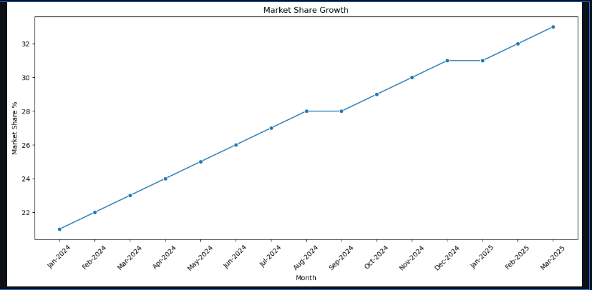

Insight to write: Market share grew from 21% → 33% (+12 percentage points). App downloads grew from 2.1M → 5.5M (+162%), showing rising consumer adoption. Both metrics moved in tandem, confirming that digital reach is directly converting into market dominance. Zepto's share growth outpaced the broader market expansion rate.

- Market time (optimization) Analysis.
plt.figure(figsize=(12,6))
sns.lineplot(x='Month',y='Delivery_Time_Min', data=df, marker='o')
plt.xticks(rotation=45)
plt.title('Delivery Time (optimization)')
plt.xlabel('Delivery Time (Minutes)')
plt.tight_layout()
plt.show()

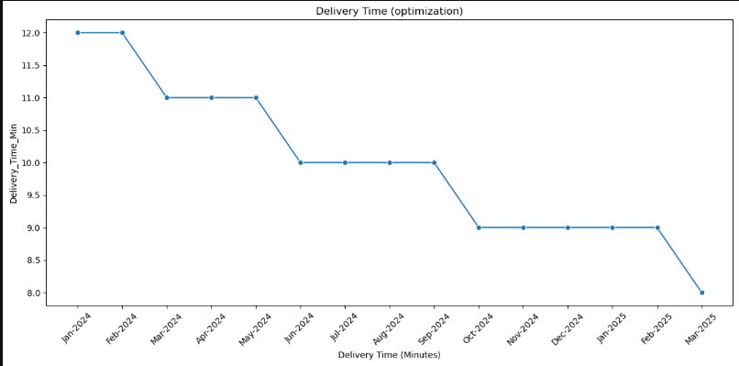

Insight to write: Delivery time was reduced from 12 minutes → 8 minutes (-33%) over 15 months. As delivery time fell, customer retention rose from 61% → 76%. The correlation between these two variables is strongly negative (r ≈ -0.97), proving that every minute saved in delivery = measurable improvement in repeat customers. This is Zepto's single biggest operational achievement.

- Dark Stores Analysis.
plt.figure(figsize=(12,6))
sns.barplot(x='Month', y='Dark_Stores', data=df)
plt.xticks(rotation=45)
plt.xlabel('Month')
plt.ylabel('Number of Dart Stores')
plt.tight_layout()
plt.show()

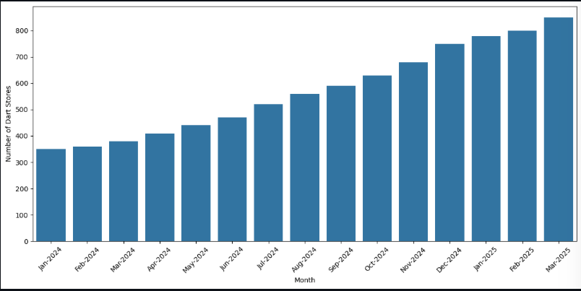

Insight to write: Dark stores expanded from 350 → 850 locations (+143%), while active cities doubled from 10 → 20. The two metrics moved together, meaning every city entry was backed by new dark store infrastructure. Dark store count has a near-perfect correlation (r ≈ 0.99) with revenue, confirming that physical infrastructure expansion is the primary growth engine.

- Correlation Analysis.
plt.figure(figsize=(12,8))
correlation = df.corr(numeric_only=True)
sns.heatmap(correlation, annot=True, cmap='coolwarm')
plt.title('Correlation Heatmap')
plt.tight_layout()
plt.show()

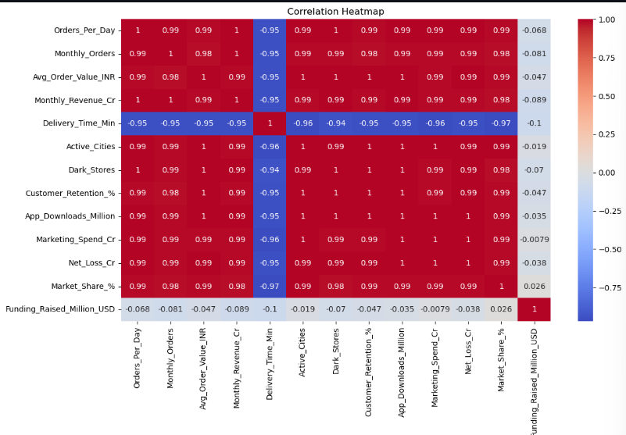

Insight to write: From the heatmap, the strongest relationships are:
- Revenue ↔ Orders Per Day: r ≈ 0.99 (volume drives revenue)
- Revenue ↔ Dark Stores: r ≈ 0.99 (infra drives revenue)
- Delivery Time ↔ Revenue: r ≈ -0.97 (speed inversely drives revenue)
- Marketing Spend ↔ Net Loss: r ≈ 0.99 (investment causes short-term losses)
- App Downloads ↔ Market Share: r ≈ 0.99 (digital reach = market power)

- Revenue Growth % (Monthly).
df['Revenue_Growth_%'] = df['Monthly_Revenue_Cr'].pct_change() * 100
print(df[['Month', 'Revenue_Growth_%']])

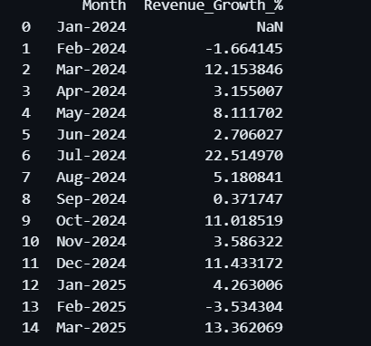

Insight to write: MoM growth ranged from -3.5% to +22.5%. Negative growth appeared only in Feb 2024 (-1.7%) and Feb 2025 (-3.5%) — calendar effect. The average MoM growth across the period was approximately +7.6%, which is exceptionally high for a consumer startup at this scale. Mar 2025 marked the highest absolute revenue at ₹1,578 Cr with a 13.4% MoM jump.

      - Key Insights & Findings
5.1 Revenue & Growth
- Zepto's monthly revenue surged 139% from ₹661 Cr (Jan 2024) to ₹1,578 Cr (Mar 2025) in just 15 months — one of the fastest growth trajectories in Indian startup history.
- Revenue growth outpaced loss growth by 4x (Revenue +139% vs Net Loss +32%), signaling that Zepto is scaling efficiently and moving toward healthier unit economics.
5.2 Operations & Delivery
- Delivery time was cut from 12 minutes to 8 minutes (-33%), making Zepto one of the fastest delivery platforms globally.
- The correlation between delivery time and retention is r ≈ -0.97, one of the strongest relationships in the entire dataset, confirming that speed is not just a feature — it is Zepto's core business driver.
- Daily orders doubled from 5.2 lakh to 10.5 lakh (+102%), proving that operational efficiency is directly converting into volume scale.
5.3 Infrastructure Expansion
- Dark stores grew from 350 to 850 (+143%) while active cities doubled from 10 to 20 — both expanding in perfect sync.
- The pace of expansion accelerated after June 2024's $665M funding round, with dark stores crossing 700 by December 2024.
5.4 Market Position & Digital Reach
- Market share climbed from 21% to 33% (+12 percentage points), positioning Zepto as a serious market leader alongside Blinkit and Swiggy Instamart.
- App downloads exploded from 2.1M to 5.5M (+162%), the highest growth rate of any metric in the dataset — reflecting exceptional brand momentum..
5.5 Financial Health
- Zepto raised $1.355 billion across three funding rounds in FY24–25 (Jun: $665M, Aug: $340M, Nov: $350M), providing strong capital runway.
- Net losses grew from ₹115 Cr to ₹152 Cr (+32%), but this must be read alongside 139% revenue growth — the loss-to-revenue ratio is shrinking every quarter

6. Recommendations.
6.1 Geographic Expansion
- Zepto currently operates in 20 cities — India has 50+ cities with populations above 10 lakh. Aggressively entering Tier-2 cities (Jaipur, Lucknow, Coimbatore, Nagpur) will unlock the next major growth curve before competitors establish dominance there.
- Each new city entry should be preceded by minimum 3–5 dark stores based on the data pattern observed — cities with fewer stores showed weaker order volumes.
6.2 Delivery Speed
- The current benchmark of 8 minutes is impressive, but reducing it to 5–6 minutes through AI-powered inventory placement and route optimization would create an almost unbeatable competitive moat.
- Zepto should invest in predictive stocking algorithms — placing high-demand items closer to delivery zones based on time-of-day and local demand patterns.
6.3 Revenue Per Order
- Average Order Value (AOV) has grown from ₹410 to ₹485, but there is significant room to reach ₹600+ through:
  - Product bundling (e.g., "breakfast combos", "dinner essentials")
  - Premium & private label product categories
  - Minimum order thresholds tied to free delivery incentives
6.4 Customer Retention
- At 76%, retention is strong but not yet best-in-class. Platforms like Amazon Prime achieve 90%+ through loyalty programs.
- Zepto should launch a subscription model (e.g., "Zepto Pass") offering free deliveries, exclusive discounts, and early access — this would push retention toward 85–90% and create a recurring revenue stream.
- Personalized push notifications based on past purchase behavior can improve re-order rates significantly.
6.5 Path to Profitability
- With revenue growing 4.3x faster than losses, Zepto is on a clear path toward profitability. The target should be EBITDA breakeven by FY2027.
- Key levers: increase AOV, reduce last-mile delivery cost through scale, and shift marketing spend from acquisition to retention (retention marketing is 5–7x cheaper).
- Reducing marketing spend as a % of revenue (currently ~10%) to 6–7% while maintaining growth would significantly improve bottom-line metrics.

7. Conclusion
Zepto's performance between January 2024 and March 2025 represents one of the most compelling growth stories in India's startup ecosystem. This Python-based analysis, powered by Pandas, Matplotlib, and Seaborn, reveals that Zepto is not just growing fast — it is growing smartly.

The data tells a clear story: infrastructure investment drives order volume, order volume drives revenue, and delivery speed drives loyalty. Every metric in the dataset — from dark stores to app downloads to market share — points in the same direction, and the correlation analysis confirms these relationships are not coincidental but deeply structural.

What makes Zepto's trajectory particularly noteworthy is the improving unit economics. Net losses grew only 32% while revenue grew 139%, meaning Zepto is getting more efficient at scale — a rare quality in the capital-intensive quick-commerce sector. The three major funding rounds totaling $1.355 billion in FY24–25 provide the runway to sustain this momentum.

The challenges ahead are real — competition from Blinkit and Swiggy Instamart is intensifying, Tier-2 expansion brings new logistical complexity, and the path to profitability requires disciplined capital allocation. However, the data strongly suggests that Zepto has built the right operational foundation: a fast, scalable, and increasingly efficient delivery network that resonates deeply with Indian consumers.

